**ASSIGNMENT-3**

**Bucket And Watson assistant Questions:**

**1.Create a Bucket in IBM object storage.**

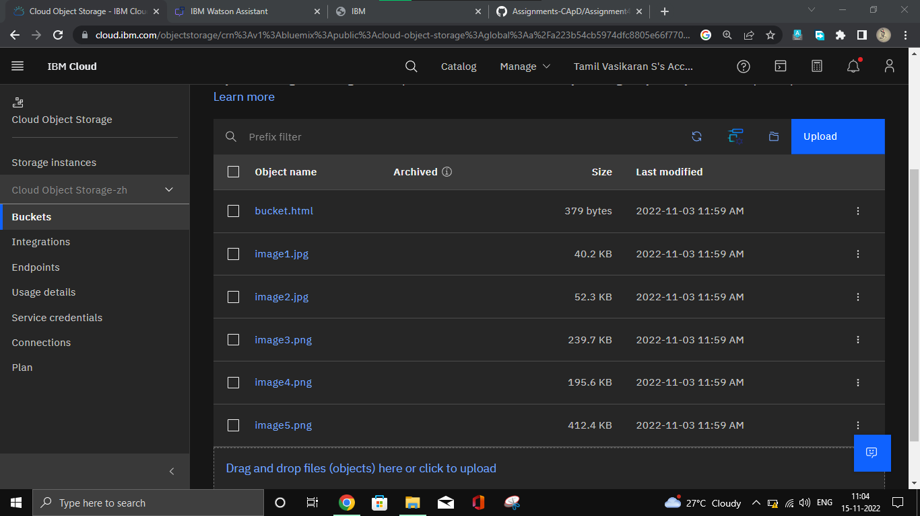

**Chatbot Creation:**

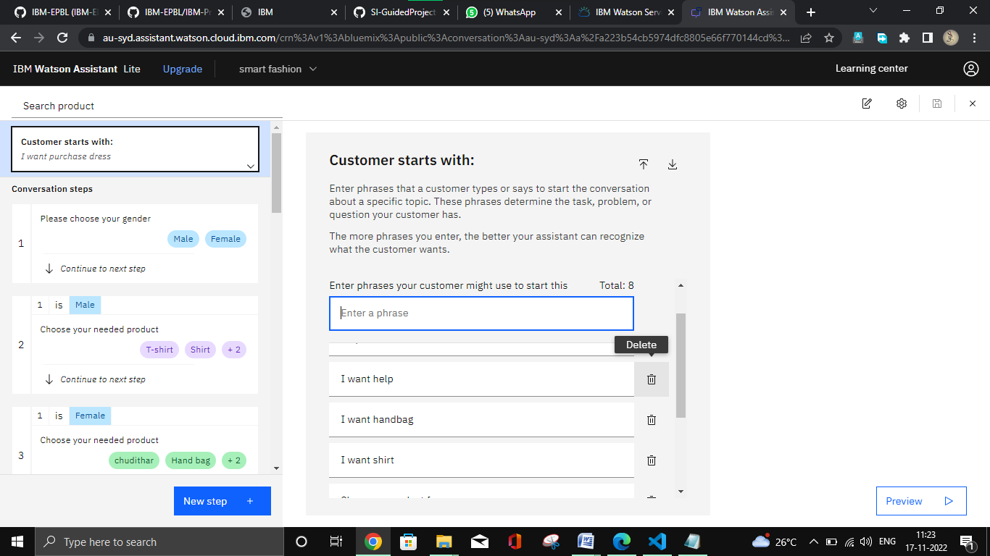

2.Upload an 5 images to ibm object storage and make it public. Write html code to displaying all the 5 images.

<!DOCTYPE html>

<html lang="en">

<head>

    <meta charset="UTF-8">

        <style>

        body {

        background-color: aqua;

        display: flex;

        align-items: center;

        justify-content: center;

        flex-direction: column;

        }

         Img

         {

         height: 250px;

         border-radius: 10px;

         margin: 4px;

        </style>

        <h1>Welcome our Smart fashion</h1>

</head>

<body>

    <dvi>

    <img src="image3.jpg" alt="image" width="250">

    <img src="image2.jpg" alt="image" width="250">

    <img src="image1.png" alt="image" width="250">

    <img src="image4.jpg" alt="image" width="250">

    <img src="image5.jpeg" alt="image" width="250">

    </dvi>

    <h2>CHAT BOT</h2>

    <p><a href="https://web-chat.global.assistant.watson.appdomain.cloud/preview.html?backgroundImageURL=https%3A%2F%2Fau-syd.assistant.watson.cloud.ibm.com%2Fpublic%2Fimages%2Fupx-63714420-dc14-4e69-b4c8-2d0e05dde353%3A%3A76a85bb0-d76b-40e7-a8f2-199b403151bd&integrationID=7810b975-01fc-4d29-9ac2-0a8692580e8b&region=au-syd&serviceInstanceID=63714420-dc14-4e69-b4c8-2d0e05dde353">click here</a></p>

</body>

</html>

Chatbot Link: <https://web-chat.global.assistant.watson.appdomain.cloud/preview.html?backgroundImageURL=https%3A%2F%2Fau-syd.assistant.watson.cloud.ibm.com%2Fpublic%2Fimages%2Fupx-63714420-dc14-4e69-b4c8-2d0e05dde353%3A%3A76a85bb0-d76b-40e7-a8f2-199b403151bd&integrationID=7810b975-01fc-4d29-9ac2-0a8692580e8b&region=au-syd&serviceInstanceID=63714420-dc14-4e69-b4c8-2d0e05dde353>

**Output:**

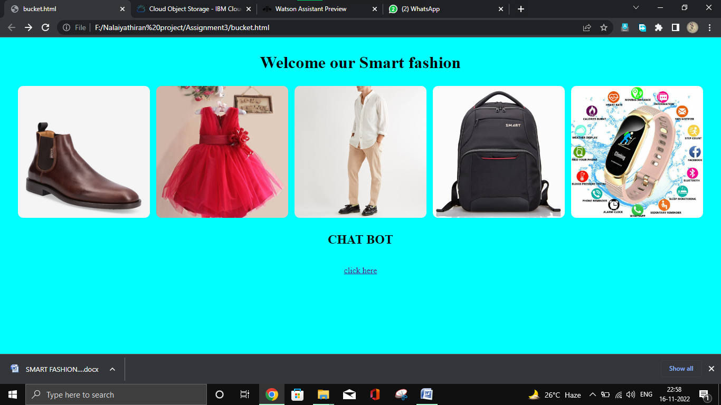

**Chatbot Output:**

